MEDICAL IMAGE ANALYSIS & PREDICTION FOR HUMAN SKIN DISEASES

A PROJECT REPORT

By - Akshat Jain

1. ABSTRACT

The study on medical image analysis addresses the pressing issue of skin diseases, emphasizing the importance of early and accurate diagnosis. Traditional methods like visual examination and biopsy are often time-consuming, prompting exploration into the promising realm of artificial intelligence (AI) for skin disease classification. Leveraging transfer learning with the "Dermnet" dataset, this research employs DenseNet201 and VGG16 models, optimizing them with the Adam optimizer and implementing early termination. Despite challenges, particularly in data variability, the study demonstrates significant potential for classifying dermatological diseases, with VGG16 exhibiting notable accuracy. This work not only transforms the medical landscape but also holds the promise of aiding healthcare professionals in making informed decisions for improved patient outcomes. Future endeavors involve expanding the database and incorporating advanced treatments to enhance predictive capabilities, contributing to the evolution of precision medicine for skin diseases.

1. INTRODUCTION

Skin diseases are a major health concern for people of almost all age groups. Early and accurate diagnosis is important for effective treatment and management of these skin diseases. Traditional diagnosis methods, mainly visual examination and biopsy are time-consuming and inappropriate.

In recent years, AI has emerged enormously and has proved to be a promising tool for skin disease classification. Transfer learning, which is a subfield of AI has shown remarkable results in this domain. By utilizing the knowledge and features from pre-trained models, transfer learning could accelerate and improve the accuracy of skin disease classification.

This project explores the application of transfer learning for skin disease classification using two image datasets obtained from ‘Dermnet’. One dataset consists of images of eight skin diseases while the other contains images of four skin diseases. The dataset then undergoes preprocessing using various techniques to enhance the diversity of the training data.

Employing transfer learning, we utilize the power of pre-trained models, specifically DenseNet201 for the eight-class dataset and VGG16 for the four-class dataset. These models are modified to adapt their generic features to the specific classification tasks. The proposed system is optimized using the Adam optimizer and employs categorical cross-entropy as the loss function. Early stopping is implemented to prevent overfitting and improve generalization performance.

Our results demonstrate that the proposed system achieves high accuracy in classifying skin diseases, showing the effectiveness of transfer learning in this domain. This system holds the potential to assist healthcare professionals in making informed decisions regarding patient care, potentially leading to improved patient outcomes.

1. LITERATURE REVIEW

The paper presents a deep learning system using CNNs and a diverse dermoscopic image dataset to automatically classify multiple skin diseases, demonstrating potential for fast, accurate, and equitable computer-assisted skin disease diagnosis.[1]

This literature paper focuses on the study of the techniques of machine learning about predicting skin diseases and recommending treatment plans. This study involves the development of a predictive model which considers various factors for treatment recommendations and accurate diagnosis. [2]

This study mainly focused on image processing applications in analyzing skin diseases. The technique of image processing that contributed to the diagnostic purposes, like from dermatological images how meaningful information can be extracted is discussed by authors in this study. [3]

This paper explores the integration of metadata and dermoscopy images for diagnosing skin diseases. It may delve into how combining clinical information (metadata) with visual data (dermoscopy images) enhances the accuracy and reliability of skin disease diagnosis.[4]

The primary focus here is on using the InceptionV3 model for the classification of skin diseases. The paper likely evaluates the performance of this specific deep learning architecture in accurately categorizing various skin conditions based on visual data.[5]

The following literature involves the development of a skin disease analyzer which is a machine learning based which also incorporates techniques of image processing. The algorithmic approach and the successfulness of the system in the analysis of automated skin diseases is discussed in this study. [6]

This paper introduces a system that uses MobileNet, a neural network architecture, for detecting skin diseases. The integration with Raspberry Pi and Telegram suggests a practical implementation for real-time monitoring or communication of skin disease detection results. [7]

This research presents a deep learning model tailored for the comprehensive diagnosis of skin diseases. Additionally, it appears to go a step further by recommending medications based on the diagnosed skin condition, showcasing a holistic approach to dermatological care.[8]

The paper focuses on the evaluation and enhancement of skin disease classification using ensemble methods. It may discuss the combination of multiple classification models to achieve higher accuracy and robustness in diagnosing different skin conditions.[9]

This paper discusses the application of deep learning methods for classifying skin diseases. It likely explores different deep learning architectures and their effectiveness in accurately categorizing and distinguishing between various dermatological conditions.[10]

1. METHODOLOGY
   1. Technology Stack

**Backend:**

Language: Python

Web Framework: Flask

**Images Pre-Processing and Analysis:**

Pandas: For data manipulation and analysis.

scikit-learn (sklearn): For machine learning tasks and preprocessing.

Image Data Generator Techniques:

1. Rescaling
2. Zooming
3. Interpolation
4. Cropping
5. Edge Detection
6. Image Segmentation
7. Morphological Processing

**Transfer Learning Models:**

DenseNet201: For the image classification among the 8 diseases prediction

VGG16: For the image classification among the 4 diseases prediction

**Web Development:**

Flask: A lightweight web framework for building web applications.

HTML: For defining the structure of web pages.

* 1. Dataset Used

Dataset - <https://www.kaggle.com/datasets/shubhamgoel27/dermnet>

This is a vast dataset containing images of 23 types of skin diseases. The total number of images is around 19,500, out of which approximately 15,500 have been split in the training set and the remaining in the test set.

From which we have taken 2 datasets - 1 with 8 classes, and another with 4 classes.

8 classes - [‘Acne and Rosacea Photos’, ‘Eczema Photos', ‘Melanoma Skin Cancer Nevi and Moles’, ‘Psoriasis pictures Lichen Planus and related diseases’, ‘chickenpox’, ‘measles’, ‘monkeypox’, ‘normal’]

Training images: 4500+ Testing images: 1200

4 classes - ['chickenpox', 'measles', 'monkeypox', 'normal']

Training Images: 2000+ Testing Images: 240

* 1. Proposed Approach

We have created 2 models- for the 8 classes dataset, we have applied the Transfer Learning approach i.e., using a pre-trained model and applying knowledge on our model without training the whole model. We have taken the DenseNet201 model and for the 4 classes dataset, we have taken the VGG16 model to implement. We basically freeze the last layers of the models and add one dense layer (to make the nodes more adapt the generic features to perform specific tasks) then apply flattening and apply SoftMax function for 4 class model and 8 classes model.

For the evaluation, we have used the Adam optimizer, Categorical cross entropy as the loss function and applied the early stopping technique.

**DenseNet201 Architecture** - DenseNet201 is made up of 201 layers comprised of dense blocks, transition layers, and a global average pooling layer followed by a dense output layer. Dense blocks consist of multiple densely connected convolutional layers.

**VGG16 Architecture** - VGG16 is made up of 16 layers, including 13 convolutional layers and 3 fully connected layers. They include Input layers, Convolutional blocks, Fully connected layers and dense Output layer

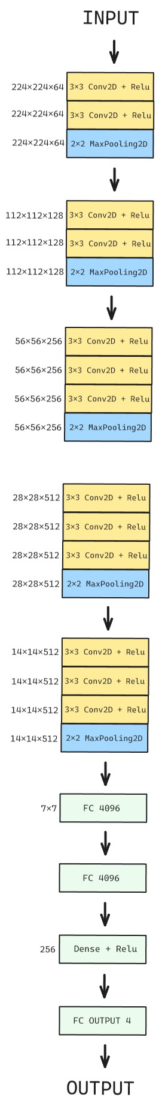

**DenseNet201 Model VGG16 Model Architecture Architecture**

1. RESULTS AND ANALYSIS

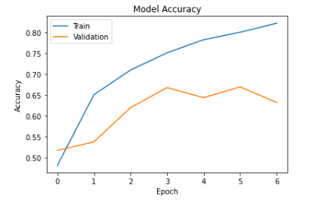**DENSENET201 MODEL**

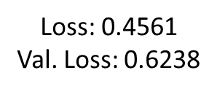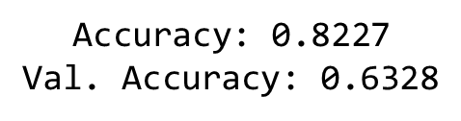

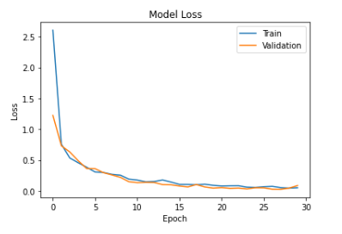 **VGG16 MODEL**

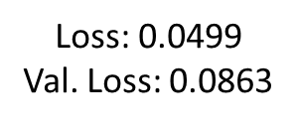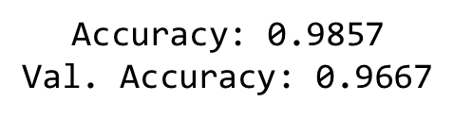

Challenges in generalization with a 63.28% validation accuracy highlight room for improvement in DenseNet201.

VGG16 demonstrates exceptional efficiency and robustness with a remarkable 96.67% validation accuracy.

1. Project Closure
   1. Limitation

CNN models only depend on the quality, diversity, and representativeness of training data due to the lack of data diversity.

Long training time so tested on fewer epochs.

8 model is only a validation dataset and does not work on any other random dataset.

* 1. Conclusion

In summary, the outlined methodology covers important aspects of building effective models for classifying skin diseases. From dataset selection and preprocessing to model training and model evaluation, every step is carefully considered to optimize performance. The basis of our approach is carefully designed and prepared samples. Using adaptive learning with DenseNet201 and VGG16, our target is not only accurate but also adaptable to different skin diseases. Integration of these pre-trained models is a good option to leverage their rich data and leverage their capabilities for specific tasks. The inclusion of research considerations, limitations, and suggestions for future research increases the completeness of the methodology and allows us to make a valuable contribution to the field of medical image analysis.

* 1. Future Scope
* Work on a bigger dataset - Increasing the size of the dataset can enhance the model's ability to generalize patterns and improve its overall performance.
* Introducing new medical hyperparameters - using new medical techniques, such as 3D images, X-ray vision, microscopy, enhanced zoom, etc., can significantly impact the performance and capabilities of your model for medical skin image analysis.
* Trying more models – Creating new models by using different dense layers, convolutional layers, and pooling layers, and also by combining the techniques of different pre-trained models to create new and advanced dermoscopic models.

By integrating cutting-edge medical hyperparameters, this project establishes a robust foundation for advancing the accuracy and depth of human skin disease predictions through image analysis.